**Virtual Reality Water Cycle Guide**

Abstract

This project is a virtual reality application which is made to educate students about the earth water cycle. It will allow user to have a visual view of the complete water cycle and its stages. Water cycle is a very important concept in our life and due to its importance, several apps have been made in this domain to teach students about the water cycle. Earlier students were taught these concepts using images and texts, which is not very elaborative, making it more complicated for the little kids to understand it. Furthermore, not many VR applications have been made in this domain and using this technology, therefore this app is beneficial for students to gain knowledge and for any other user who is interested in familiarizing himself/herself with the water cycle. Our application is divided into two major roles, one is to allow user take a tour of the water cycle and visualizing every stage. Second is a mini game which will polish up user’s knowledge in the water cycle, making the learning process entertaining as well as useful. The methodology used to fulfill this project is Rapid application development (RAD) and the expected outcome will be an informative and interactive game and a tour of water cycle in which there will be a robot companion to explain every stage.

List of Figures

[Figure 1.1: Plan-Gantt Chart 7](#_Toc15285588)

[Figure 2.1: Splash Sim app 9](file:///C:\\Users\\zaina\\OneDrive\\Documents\\university%20courses\\Capston%201\\watercycle2%5b1778%5d.docx" \l "_Toc15285589)

[Figure 2.2: Cicle de l’Aigue VR app 10](file:///C:\\Users\\zaina\\OneDrive\\Documents\\university%20courses\\Capston%201\\watercycle2%5b1778%5d.docx" \l "_Toc15285590)

[Figure 2.3: TABI the water cycle 10](file:///C:\\Users\\zaina\\OneDrive\\Documents\\university%20courses\\Capston%201\\watercycle2%5b1778%5d.docx" \l "_Toc15285591)

[Figure 2.4: วัฏจักรน้ำ (Water Cycle) 11](file:///C:\\Users\\zaina\\OneDrive\\Documents\\university%20courses\\Capston%201\\watercycle2%5b1778%5d.docx" \l "_Toc15285592)

[Figure 3.1: Main Menu Use Case Diagram 13](file:///C:\\Users\\zaina\\OneDrive\\Documents\\university%20courses\\Capston%201\\watercycle2%5b1778%5d.docx" \l "_Toc15285594)

[Figure 3.2: Game Mode Use Case Diagram 15](#_Toc15285598)

[Figure 3.3: Tour menu Use Case Diagram 17](#_Toc15285603)

[Figure 3.4: System Sequence Diagram 18](#_Toc15285606)

List of Tables

[Table 2.1: Comparison table between our app and similar apps 12](#_Toc14836137)

[Table 3.1: Tour Guide Use-Case 14](#_Toc14836138)

[Table 3.2: Start Game Use-Case 15](#_Toc14836139)

[Table 3.3: Exit Use-Case 15](#_Toc14836140)

[Table 3.4: Move Player Use-Case 16](#_Toc14836141)

[Table 3.5: Mission Completed Use-Case 16](#_Toc14836142)

[Table 3.6: Play Again Use-Case 16](#_Toc14836143)

[Table 3.7: Exit to Main Menu Use-Case 16](#_Toc14836144)

[Table 3.8: Repeat tour Use-Case 17](#_Toc14836145)

[Table 3.9: Exit to main menu Use-Case 17](#_Toc14836146)

List of Symbols / Abbreviations

VR Virtual Reality

App Application

Table of Contents

[Abstract i](#_Toc296314688)

[List of Figures ii](#_Toc985455045)

[List of Tables ii](#_Toc1910374947)

[List of Symbols / Abbreviations iii](#_Toc415398883)

[Chapters](#_Toc832963446)

[1: Introduction 1](#_Toc832963446)

[1.1 Introduction 1](#_Toc1795058862)

[1.2 Problem Statement 1](#_Toc52421822)

[1.3 Objective 1](#_Toc2107084600)

[1.4 Methodology 1](#_Toc920624232)

[1.5 Expected outcome 2](#_Toc956640608)

[1.6 Plan-Gantt chart 3](#_Toc2053229735)

[1.7 Structure of report 3](#_Toc1082687187)

[2: Literature Review 4](#_Toc1783923794)

[2.1 Introduction 4](#_Toc1024715939)

[2.2 Similar apps 4](#_Toc123056894)

[2.3 Apps comparison 8](#_Toc1179154579)

[3: Requirements Analysis 9](#_Toc1194016610)

[3.1 Introduction 9](#_Toc306682283)

[3.2 Functional Requirements 9](#_Toc1319727229)

[3.3 Non-Functional Requirements 9](#_Toc2052384454)

[3.5 System Sequence Diagram: 14](#_Toc956732151)

[4: Future Work 15](#_Toc662676305)

[4.1 Conclusion: 15](#_Toc496663524)

[4.2 Future Work: 15](#_Toc1255869042)

[References 16](#_Toc1593418450)

# **Chapter 1: Introduction**

## **1.1 Introduction**

Virtual reality (VR) is an innovation which enables a client to connect with a PC reproduced condition, regardless of whether that condition is a recreation of this present reality or a conjured-up universe. It seen as one of the key technologies that is going to shape the future of computing. It is the way to encounter, feeling and contacting the past, present and what's to come. It is the mode of making our own reality, our very own redid reality. It could go from making a computer game to having a virtual walk around the universe, from strolling through our own fantasy house to encountering a stroll on an outsider planet. With computer generated reality, we can encounter the most scary and difficult circumstances by playing safe and with a learning point of view.

As to the VR we can develop application that will help kids have a better view of the water cycle through this technology. As kids will be able to see all the stages that takes place in the water cycle. Moreover, an added game for the kids will help them understand the water cycle in better way as kids love to play games and that help them understand better than just have an explanation/imagination of the different stages of water cycle.

## **1.2 Problem Statement**

As of now there are few VR app that takes the user through a virtual tour of the water cycle which is difficult for kids when they hear about the water cycle, it is explained to them through text/pictures that makes it difficult for them to imagine how it exactly works. But if they have a chance to have a visual view of the water cycle, they will understand it easily as they will have a visual of all the stage taking place and how these stages are linked to each other.

## **1.3 Objective**

The purpose of this project is to design a Virtual Reality application for school students to learn about earth’s water cycle.

The objects of the project are:

* To develop a virtual reality application for water cycle education.
* To provide users with a game to understand water cycle
* To provide user with different mode of interaction.
* To provide user with real model view of water cycle.

## **1.4 Methodology**

In this project we will use Rapid Application Development (RAD).

RAD is a type of agile methodology. Unlike other methods that are designed to be a one-way process that must go through all the phase before coming back to the previous stage if needed. RAD is less strict on phase model, focus more over user feedback and a working software. RAD soul is based upon more action rather than more talks. Even though RAD doesn’t work based on strict planning techniques, there is many other helpful things that make this methodology more successful.

Other possible methodologies are Prototyping, waterfall, but we prefer to stick to RAD as we are on tight deadline and don’t have enough time to develop a non-working model and then work on its functionality or in waterfall model we will have to go through all phases and wait to add/remove certain elements that will harshly effect our time for project completion.

RAD WORKFLOW ----IMAGE

PHASES

1. Requirement: Users, developer, designer discuss the system/application outcome and its requirement. Once it’s all set, timeline is estimated and the budget for creating the system.
2. Building Prototypes: As soon the requirements are set, teams start working on building functional prototypes. Teams will create and improve prototypes until the final product is achieved. Testing for refining helps the team as many unnoticed bugs appear and are fixed in the next phase that eliminates most of the common issue that become difficult to fix later.
3. User feedback: As they will play an important role in system/application improvement. They will be in touch with the development teams and provide feedback of the prototype so teams can improve the prototype based on their feedback.
4. Repeating the 3 previous phases until project completion or the team has reached the mere end of the project.
5. Testing: Before launching the project, testing is done in different scenarios to ensure everything works as expected. While teams test the system/application end users are also called for testing.
6. Project release: After passing through the previous phases and everything is set as expected the project is released for client.

## **1.5 Expected outcome**

The developed application will allow students to have a tour of different phase of water cycle with help of a robot companion that will provide them with information about the different stages of the water cycle tour as the go through them. The other part which is the mini game will be where student use Bluetooth controller to play the game by controlling the player’s movement and achieving the task given to them within a certain time limit.

## **1.6 Plan-Gantt chart**

Figure 1.1: Plan-Gantt Chart

## **1.7 Structure of report**

structuredNext chapter in this report is about literature review that will include most of the similar App related to our project and a comparison table to give a better idea of the differences between the VR Apps. Chapter 3 will be requirements analysis that contains the functional and non-functional requirements leading to use-case diagram and system sequence diagram. The next chapter is the conclusion with references included as well.

# **Chapter 2: Literature Review**

## **2.1 Introduction**

Water cycle has always been an important topic in science. Teachers sometimes struggle to explain such concepts briefly as they require imagination and a complete picture of how such processes go on. So, in this domain, many applications are created in order to ease the understanding for the students as well as the teachers.

Virtual Reality (VR) is seen to be playing a great role in education. Using its various features, it has made learning of many concepts easier. Like our app, there are many VR applications created to widely expose these concepts to students and allow them virtually visit places which are distant and physically inaccessible to them. In this chapter, we will be discussing applications that are already made for users to educate them about water cycle and comparing our application and its features with them.

## **2.2 Similar apps**

Below are some applications that are similar to our application and are meant to educate students:

1. Splash Sim: A VR Experience in the Water Cycle [1]

**App description:**

This app is to teach students the water cycle by engaging them into all the cycles using virtual reality. It required the virtual reality headset to be viewed properly. It has also been optimized for google cardboard. This app explains only the three phases of water cycle (evaporation, condensation and precipitation) by a guided tour along with a text appearing on the screen.

**Features:**

* User is taken to a tour to see different phases of water cycle.
* Text is appeared to explain user about the phases.
* Audio effect of rain, wind and birds.

**Weaknesses:**

* Lack of animation in evaporation stage.
* No text to speech implementation.
* The tour gets on repeated by itself.

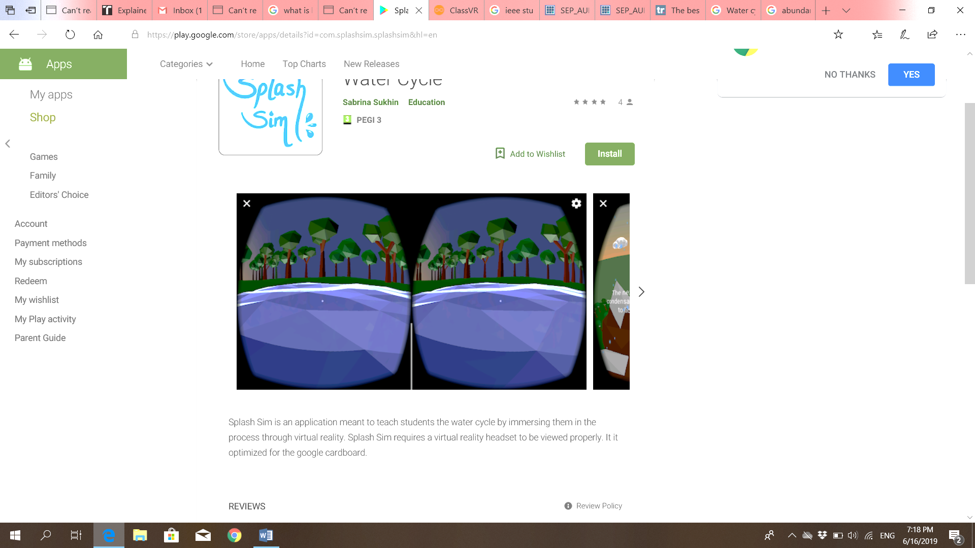

Figure 2.1: Splash Sim app

1. Cicle de l’Aigue VR (Water cycle VR) [2]

**App description:**

This app, which is in Catalan language, allows user to experience the natural cycle of water from the perspective of a drop. Water cycle VR explains and shows each phase separately with a smooth shift between. The phases are explained with the help of audio speech in Catalan language. A slight music is played in the background along with the sound effects of rain, wind and ocean to make the user engage in the environment.

**Features**:

* A guided tour to allow to the user understand all the phases of water cycle.
* An audio voice to explain user the water cycle.
* Audio effect for rain and wind.
* Main menu to allow user to choose the option they would like to go for.
* Bluetooth control.

**Weaknesses:**

* Hanging occurs while the scene is viewed from different angles.
* The app has no other language support other than Catalan language.

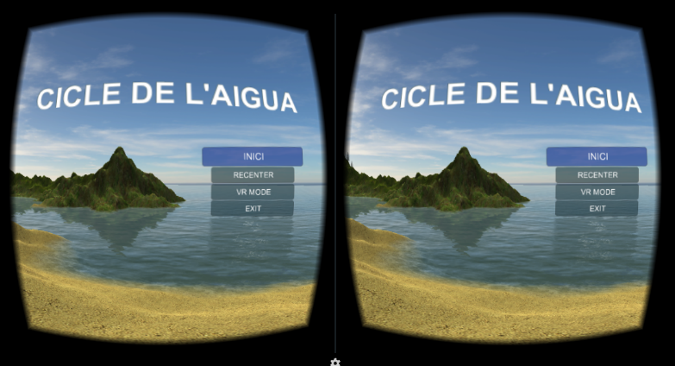

Figure 2.2: Cicle de l’Aigue VR app

1. TABI the water cycle [3]

**App description:**

This app teaches user how the water behaves in our world. Basically, it’s a game based app to allow user interact and observe the different phases of water cycle. The user is asked to perform a function to see the result and the result is nothing but the phases of water cycle. It teaches the phases precipitation, condensation and evaporation and how one phase changes to another.

**Features:**

* User plays a game to create evaporation, condensation and precipitation.
* Text shown at the beginning to guide the user to play the game.

**Weaknesses:**

* Not a VR app.
* 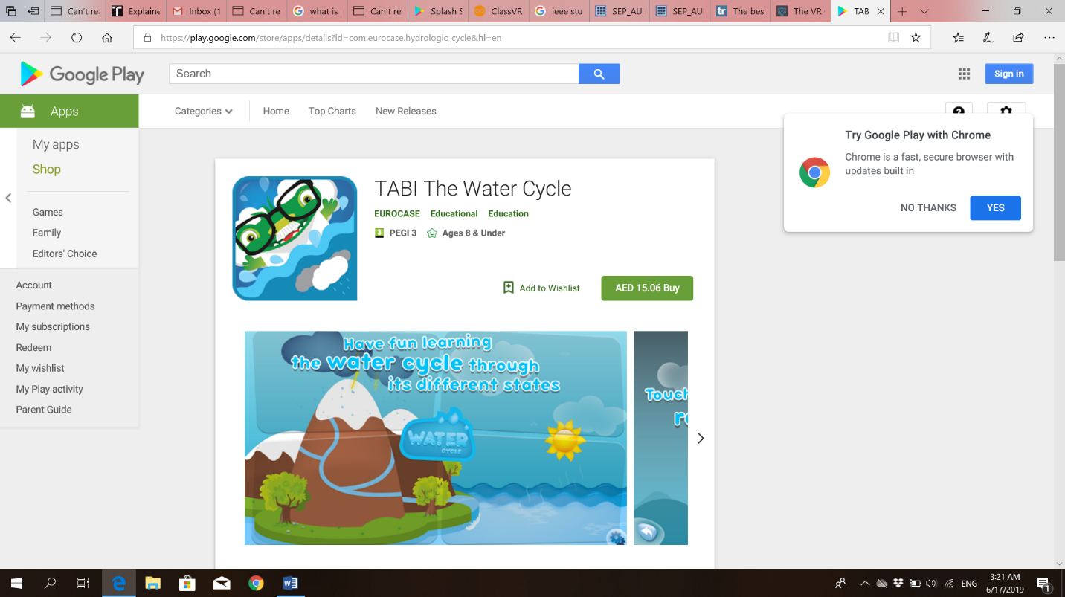It doesn’t show the complete water cycle at once and how a stage transforms into another.

Figure 2.3: TABI the water cycle

1. วัฏจักรน้ำ (Water Cycle) [4]

**App description:**

This app based on Thai language, contains multimedia lessons of water cycle to help students learn water cycle. These lessons explain the meaning of water cycle, the processes and factors of water cycle. It also includes a game to allow students interact with the app and understand the phases more clearly through playing the game.

**Features:**

* Main menu to allow user to choose where they want to go.
* Lessons about water cycle explaining the phases.
* Game to educate user more about water and to allow them to understand it more.
* Audio speech to engage then user more in the app and explain each step clearly.

**Weaknesses:**

* No language support other than Thai language.
* Not a VR app.
* All phases are not shown continually to explain the transformation between them.

**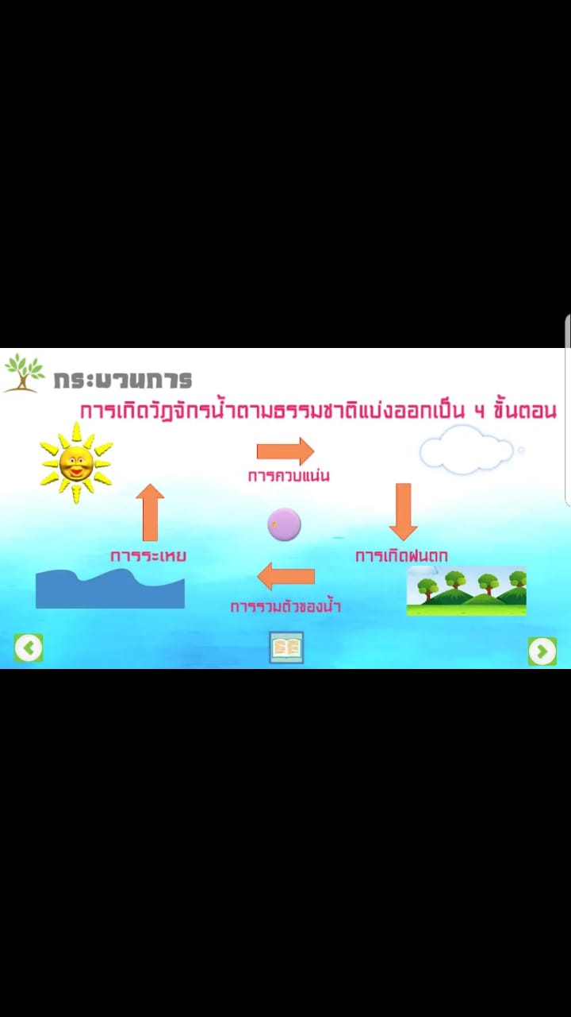**

Figure 2.4: วัฏจักรน้ำ (Water Cycle)

## **2.3 Apps comparison**

Here is comparison table of our app with the already existing water cycle apps showing the similarities and differences between the apps and distinguishing the unique features of our app.

|  |  |  |  |  |  |
| --- | --- | --- | --- | --- | --- |
| Features\ Apps | Splash Sim | Cicle de l’Aigue VR | TABI the water cycle | วัฏจักรน้ำ (Water Cycle ) | VR Water Cycle tour and game (Our app) |
| VR app | ✓ | ✓ |  |  | ✓ |
| Interactivity implementation | ✓ | ✓ |  |  | ✓ |
| Main menu |  | ✓ | ✓ | ✓ | ✓ |
| Phase Explanatory text | ✓ |  | ✓ | ✓ | ✓ |
| Guided tour | ✓ | ✓ |  |  | ✓ |
| Educative Game |  |  | ✓ | ✓ | ✓ |
| Animation | ✓ | ✓ | ✓ | ✓ | ✓ |
| Robot companion |  |  |  |  | ✓ |
| Text to speech implementation |  | ✓ |  | ✓ |  |

Table 2.1: Comparison table between our app and similar apps

# **Chapter 3: Requirements Analysis**

## **3.1 Introduction**

In this chapter we will discuss more about the functional and nonfunctional requirements of the application. Use case diagram and table along with system sequence diagram that will give a brief detail of the requirements and how it will be further implemented.

## **3.2 Functional Requirements**

requirements

Main Menu:

R1: The application shall allow user to select Tour Guide/Game or Exit the application

Tour Guide:

R2: The application shall guide the user with robot companion.

R3: The application shall pass the user through all the water cycle phases.

R4: The application shall allow user to look around.

Mini Game:

R5: The application shall allow user to move player as needed.

R6: The application shall limit user gameplay time.

R7: The application must record user gameplay time for high score.

## **3.3 Non-Functional Requirements**

The application must not lag for more than 0.002 seconds

**3.4 Use case diagram**

Main Menu Use Case Diagram

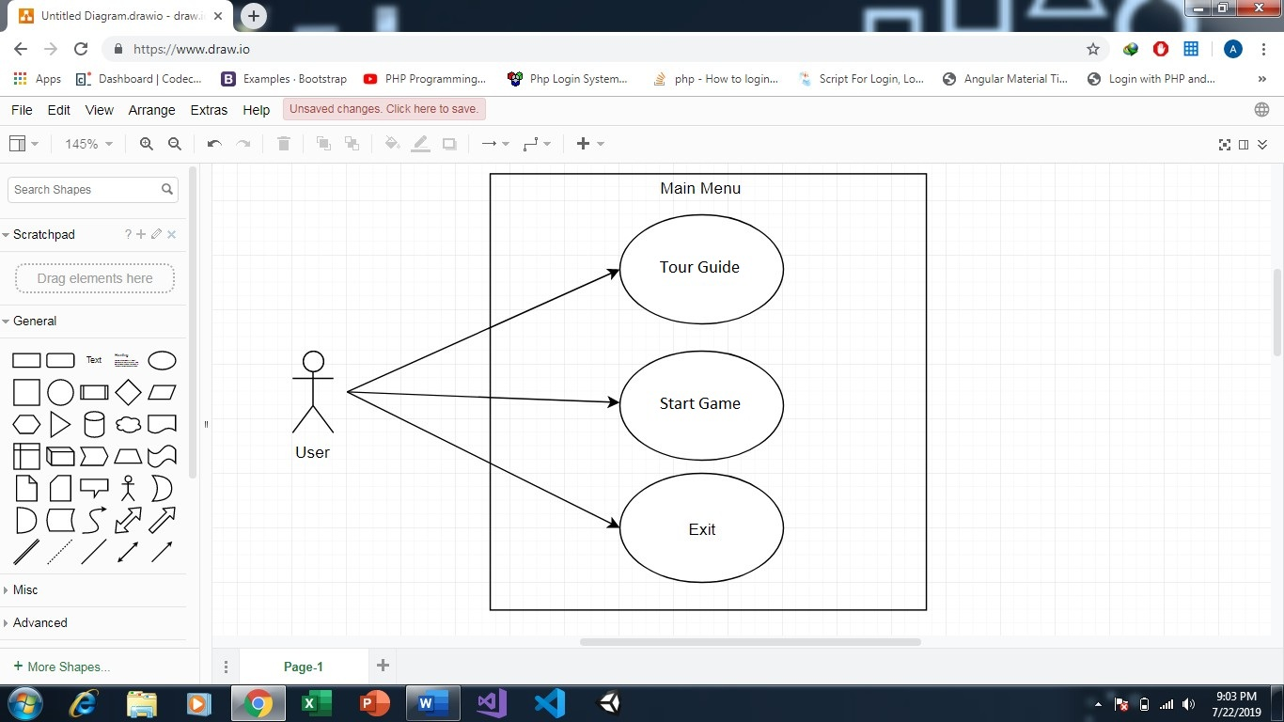

Figure 3.1: Main Menu Use Case Diagram

|  |  |
| --- | --- |
| Use Case ID | 1 |
| Use Case Name | Tour Guide |
| Actor | User |
| Description | This describe the process that allows user to start tour |
| Pre-Condition | User loads the application |
| Flow of Events | 1.User looks at Start Tour button for 0.2 seconds |
| Post-Condition | The application will start the tour |
| Alternative Flow | - |
| Assumptions | - |

Table 3.1: Tour Guide Use-Case

|  |  |
| --- | --- |
| Use Case ID | 2 |
| Use Case Name | Start Game |
| Actor | User |
| Description | This describe the process that allows user to start tour |
| Pre-Condition | User loads the application |
| Flow of Events | 1.User looks at Start Game button for 0.2 seconds |
| Post-Condition | The application will start the tour |
| Alternative Flow | - |
| Assumptions | - |

Table 3.2: Start Game Use-Case

|  |  |
| --- | --- |
| Use Case ID | 3 |
| Use Case Name | Exit |
| Actor | User |
| Description | This describe the process that allows user to exit application |
| Pre-Condition | User loads the application |
| Flow of Events | 1.User looks at exit button for 0.2 seconds |
| Post-Condition | The application will exit |
| Alternative Flow | - |
| Assumptions | - |

Table 3.3: Exit Use-Case

Game Mode

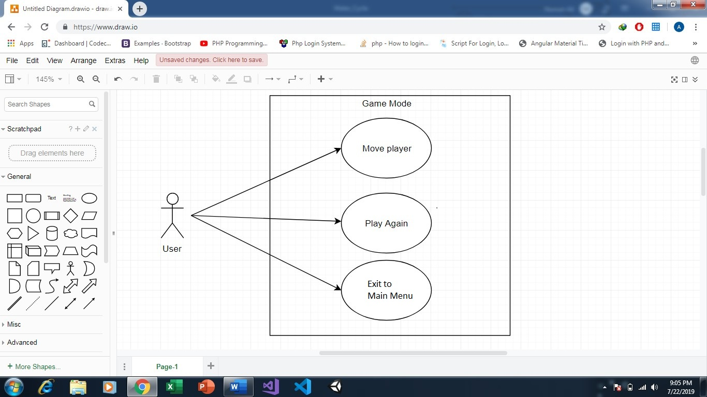

Figure 3.2: Game Mode Use Case Diagram

|  |  |
| --- | --- |
| Use Case ID | 4 |
| Use Case Name | Move Player |
| Actor | User |
| Description | This describe the process that allows user to move player to complete mission |
| Pre-Condition | 1. User loads the application  2. User clicks on Start Game button |
| Flow of Events | 1.User moves the player as needed to complete mission |
| Post-Condition | The application will display time taken (high score) to complete task |
| Alternative Flow | 1. User fails to complete mission in time provided |
| Assumptions | - |

Table 3.4: Move Player Use-Case

|  |  |
| --- | --- |
| Use Case ID | 5 |
| Use Case Name | Mission Completed |
| Actor | User |
| Description | This describe the process that takes place after user passed the mission |
| Pre-Condition | 1. User loads the application  2. User clicks on Start Game button  3. User completes the mission |
| Flow of Events | 1.User is redirected to Main Menu |
| Post-Condition | - |
| Alternative Flow | - |
| Assumptions | - |

Table 3.5: Mission Completed Use-Case

|  |  |
| --- | --- |
| Use Case ID | 6 |
| Use Case Name | Play Again |
| Actor | User |
| Description | This describe the process that allows user to Play Game after first try |
| Pre-Condition | User fails in first attempt |
| Flow of Events | 1.User press C button Play Again. |
| Post-Condition | The Game will restart |
| Alternative Flow | - |
| Assumptions | - |

Table 3.6: Play Again Use-Case

|  |  |
| --- | --- |
| Use Case ID | 7 |
| Use Case Name | Exit to main menu |
| Actor | User |
| Description | This describe the process that allows user to exit game and load main menu |
| Pre-Condition | User fails in first attempt |
| Flow of Events | 1.User press A button to load Main Menu. |
| Post-Condition | The Game will exit and load main menu |
| Alternative Flow | - |
| Assumptions | - |

Table 3.7: Exit to Main Menu Use-Case

Tour Menu Use Case

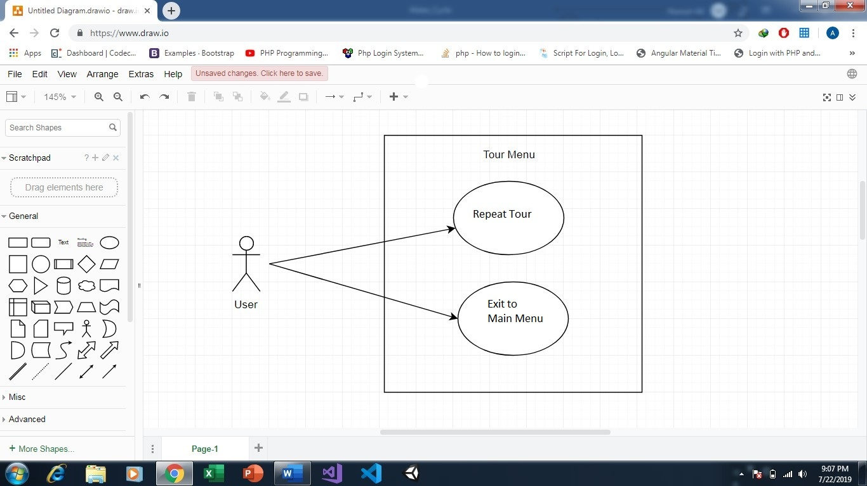

Figure 3.3: Tour menu Use Case Diagram

|  |  |
| --- | --- |
| Use Case ID | 8 |
| Use Case Name | Repeat tour |
| Actor | User |
| Description | This describe the process that allows user to restart tour |
| Pre-Condition | 1. User loads the application  2. User click Tour Guide button  3. Tour ends |
| Flow of Events | 1.User press C button to Repeat Tour. |
| Post-Condition | The tour will restart. |
| Alternative Flow | - |
| Assumptions | - |

Table 3.8: Repeat tour Use-Case

|  |  |
| --- | --- |
| Use Case ID | 9 |
| Use Case Name | Exit to Main Menu |
| Actor | User |
| Description | This describe the process that allows user to exit tour and load main menu |
| Pre-Condition | 1.User loads the application  2. User click Tour Guide button  3. Tour ends |
| Flow of Events | 1.User press A button to Main Menu. |
| Post-Condition | The application will exit tour and load main menu |
| Alternative Flow | - |
| Assumptions | - |

Table 3.9: Exit to main menu Use-Case

## **3.5 System Sequence Diagram:**

The system sequence diagram shown below reveals the sequence of actions, their order and events generated by external actors, to fulfill all the tasks of our water cycle VR app.



Figure 3.4: System Sequence Diagram

# **Chapter 4: Future Work**

## **4.1 Conclusion:**

In this report we have identified the problem and used the most suitable and advanced solution to overcome the problem which is to create a VR app to ease the understanding and expand the knowledge of water cycle to the students. Furthermore, the RAD methodology was used due to its significant advantage in software developing. Literature review was given a considerable duration to get domain knowledge and see what previous work has been done in the domain. In addition, we have used various computer tools and techniques in order to build charts, diagrams, etc.

## **4.2 Future Work:**

The work to be continued involves translating the requirements specifications into an implementable design. Prototypes will be built to get users’ feedbacks and improve the prototypes according to the responses. The most important phase in future work is implementation in which we will be using most suitable programming language and technology. Another important phase is testing in which the software’s validity and verifiability is tested using different software strategies and metrics.

# **References**

|  |  |
| --- | --- |
| [1] | S. Sukhin, "Splash Sim: A VR Experience in the Water Cycle - Apps on Google Play," Google, 10 2017. [Online]. Available: https://play.google.com/store/apps/details?id=com.splashsim.splashsim&hl=en\_US. [Accessed 28 7 2019]. |
| [2] | A. V. Education, "Cicle de l'Aigua VR - Apps on Google Play," Google, 1 2016. [Online]. Available: https://play.google.com/store/apps/details?id=com.allvreducation.cicledelaigua&hl=en. [Accessed 28 7 2019]. |
| [3] | EUROCASE, "TABI The Water Cycle - Apps on Google Play," Google, 1 2016. [Online]. Available: https://play.google.com/store/apps/details?id=com.eurocase.hydrologic\_cycle&hl=en. [Accessed 28 7 2019]. |
| [4] | S. Xpert, "วัฏจักรน้ำ (Water Cycle) - Apps on Google Play," Google, 10 2018. [Online]. Available: https://play.google.com/store/apps/details?id=com.studioxpert.watercycle. [Accessed 28 7 2019]. |
|  |  |